# Inspector User Manual

*Yaroslav Lyutvinskiy 2019-05-02*

Inspector is a simple extracted chromatogram viewer intended for exploring and curation LC-MS experimental data. It works together with mzAccess web-service to provide fast visualization of native raw LC-MS data. Working together with mzAccess web-service and IsoTrack untargeted metabolomics analysis software, it provides convenient ecosystem for metabolomics data analysis and data curation

## Overview

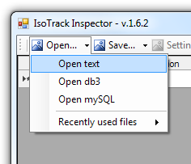Inspector is published on github [<https://github.com/Yaroslav-Lyutvinskiy/mzAccess-Inspector>] in a ready-to-try fashion. To start with it, you should download binary folder [<https://github.com/Yaroslav-Lyutvinskiy/mzAccess-Inspector/tree/master/Inspector/bin>] with all the files, run the program Inspector.exe, and then, as shown in the figure to the left, open text file “Deep Labeling.txt” from that folder. This file contains description of substances found in experiment, and their RT-MZ coordinates in data files. Actual raw data are hosted on mzAccess web-service. Inspector connects to that web-service and retrieves data dynamically.

“Deep Labeling.txt” file contains data obtained in deep labeling experiment described in [[1]]. Briefly, data set for this experiment contains LC-MS runs of metabolite extractions of cell lysates measured both in positive and negative MS modes. There are one triplicate of unlabeled samples and one triplicate of samples of cells grown at cell medium uniformly labeled by 13C in glucose and all 20 amino acids. Also there is one blank sample. Known metabolites identified with standards have abbreviation in “Name” column. Unknown metabolites originated from untargeted analysis marked by number in names and only have putative identification by exact mass.

*Technical Note: Inspector.exe is compiled as 64-bit dotNet Application. To run it you need 64-bit Windows 7 or higher and dotNet of v. 4.5.2 installed. You can setup dotNet from* [*here*](https://www.microsoft.com/en-us/download/details.aspx?id=42642)*.*

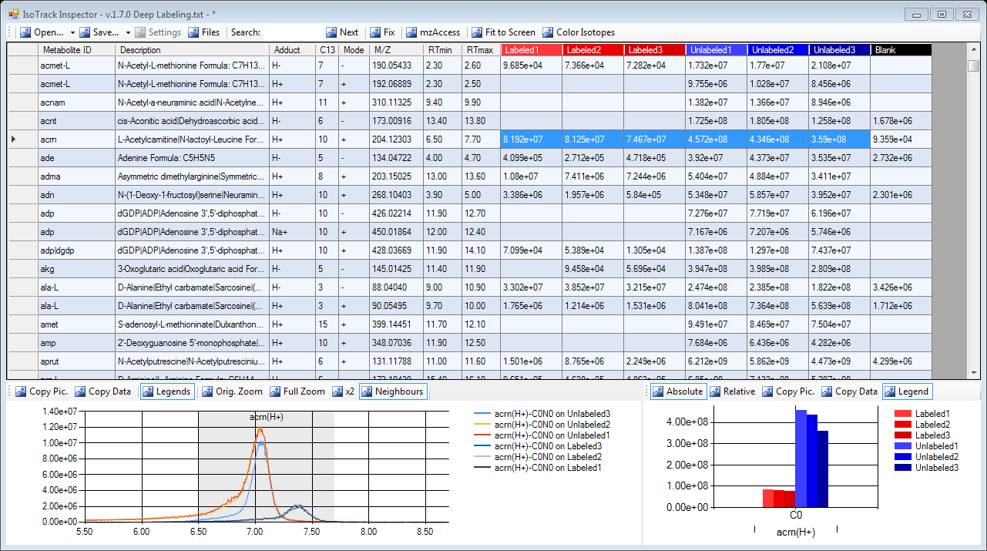

After you opened the file, you will get access to the main screen of Inspector as shown in the figure above. Here you see data grid where several first columns are description of target substances, and then there are columns with ion current summed in provided RT-MZ coordinates of sample data files.

If you select some cells in ion current area, then corresponding extracted chromatogram of elution profile will be shown on the left bottom panel and corresponding ion current values will be shown on the bar chart on the right bottom panel.

Most of information provided can be exported in text and/or graphic form. All the parameters can changed and, later, saved. Information that is more detailed will be provided below.

## User Manual

### Input Data

As a main option of input data, Inspector has simple tab-delimited text files, which can be prepared, for example, in Excel or in any text editor. These files contain two section: First, list of raw data files, second, compound description with MZ-RT coordinates in raw files.

First section: For initial loading just place here simple list of the file as they loaded to your mzAccess web-service. File names can be specified with or without path, with or without extension, one file name per line in a way like that:

160215_LCMS_QE_pHILIC_Nina_Complete_Labeling_Neg_57.raw

160215_LCMS_QE_pHILIC_Nina_Complete_Labeling_Neg_58.raw

…

Later, after “Setting up experiment details” file names, Isotrack will add experiment details in XML-like format to the text file.

Second section is a tab-delimited table of compounds you will work with in Inspector. This table should contain following columns:

NAME – unique identifier of your compound

ADDUCT – This field is intended for specifying ion forming adduct, which makes your molecule to be a charged ions. Most common adducts are “H+”, “H-”, “Na+” etc. The value of this field can be arbitrary string or even left blank. However, for proper functioning of Inspector, the combination of NAME and ADDUCT field have to be **unique**. For example, unique compound “NADH” can have two different forms protonated “H+” and deprotonated “H-”. If you like to see both of them you have to fill two strings in the table “NADH” “H+” and “NADH” “H-”.

MODE – Can be either “+” for positive MS mode or “-” for negative MS mode. According to Mode, Inspector will search for compounds in negative mode raw data files or in positive ones.

DESC – Free-form description of compound. You can fill this field with whatever notes you like. (don’t use [TAB] in description)

MZ – mass-to-charge value for the first, pure 12C isotopomer of the ion (monoisotopic mass). It is important to specify it accurate enough. Five digits after decimal point will be a good choice.

RTMIN – time in minutes of LC-MS experiment when elution of compound starts.

RTMAX – time in minutes of LC-MS experiment when elution of compound finishes.

C13TOCHECK – Number of 13C isotopes to check for target compound. Usually it corresponds to number of carbon atoms in molecule.

Here is an example how the table can be filled:

NAME DESC ADDUCT MODE MZ RTMIN RTMAX C13TOCHECK

1madn 1-methyladenosine +H + 282.1197 2.4 3.35 11

ade Adenine +H + 136.0618 4.48 5.15 5

ade Adenine -H - 134.0472 4.48 5.15 5

You can start your own table copy-and-pasting this table to text document or Excel. In case of Excel, save the file in text tab-delimited format.

Order of the columns does not matter. Additional columns if they are there will be ignored and will not be saved later.

Isotrack software produces output files compatible with Inspector. You can use such files directly without editing.

### Setting up Experiment Details

For more convenient exploring experiment results, you can setup some preferences on result visualization. To do it press the button “Files” at the top of main window. The Files dialog window will appear.

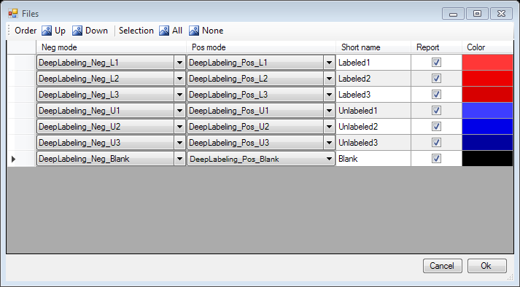

Every string in a table in the “Files” window correspond to one sample in your experiment, and therefore to one column in main window.

**“Neg mode”, “Pos mode”** – Inspector design suggest that every sample can be measured twice, in positive and negative mass spectrometry modes. Here you can set up pairing of files in different modes for each sample. To do it, choose the negative and positive mode raw data files from the drop-down list in “Neg mode” and “Pos mode” columns, respectively. Selection can be cleared if you choose first empty string of list.

**“Short name”** – Here you can enter a short name for your sample. This name will be used for your sample in main Inspector window.

**“Report”** – this column allows you to choose if particular sample will be reflected in main program window. You can change value of that column at any time. Buttons “Selection All” and “Selection None” at the top of the window will check or clear all the checkbox in this column.

**“Color”** – set up the color, which will be used for column caption and bar chart in main window. Click on that column and choose color in appearing Color Dialog Box. It is a good idea to use similar colors for replicates to group them visually together.

You can also arrange order of the column in the main window with buttons **“Order Up”** and **“Order down”** at top of the window”

All the information filled in this window will be saved to the first section of your text document in XML-like format. If you wish, you can change it manually, but be aware that if your editions will violate XML format, Inspector will not be able to load that file.

### mzAccess Connection

mzAccess is the source of all actual mass spectrometry data for Inspector. The window of mzAccess connection and tuning is available by pressing button “mzAccess” at the top of main window. mzAccess option window is shown below:

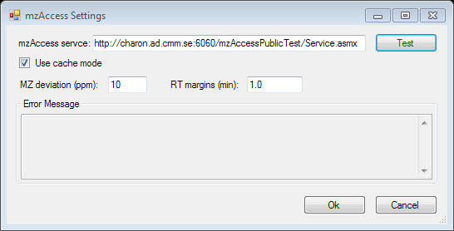

By default, Inspector connects to a test mzAccess instance <http://charon.ad.cmm.se:6060/mzAccessPublicTest/Service.asmx> hosted by the Nilsson lab (Karolinska Institutet, Sweden). This mzAccess instance holds data for the demo text files supplied with Inspector. If you have set up mzAccess locally from installation package at [www.mzAccess.org](http://www.mzAccess.org) you should change service path to <http://localhost/mzAccess/Service.asmx>. Otherwise, you should change it to Service.asmx page of your mzAccess instance as it available in your network.

After changing the path to mzAccess, you can test connection pressing button “Test”. If connection is successful, caption of “Test” button becomes green. Otherwise, it will be red and error message will appear at panel below.

**“Use cache mode”** checkbox switch mzAccess to internally cached data instead of true raw files. It will provide you significant speed gain at the price of some hard disk space (~20% of raw files) on mzAccess service. For details, look at mzAccess reference at <https://github.com/Yaroslav-Lyutvinskiy/mzAccess/blob/master/Web-service%20API%20reference%20V.1.5.pdf>.

**“MZ deviation (ppm)” –** parameter sets mass window, which will be used to extract elution profile of compound. That roughly correspond to the mass accuracy of instrument used to obtain mass spectrometry data. Reasonable value for Orbitrab data is 10 ppm, for TOF MS data 10-30 ppm depending on instrument model and settings.

**“RT margins (min)”** – this parameter defines retention time window, which will be initially loaded when you request Inspector for compound elution profile. Inspector will load profile for compound plus RT margins before and after boundaries for elution time. For LC-MS runs of about totally 20 minutes, reasonable margin is about 1 minute.

### Main Window Navigation Technique

#### Main Table

The largest part of the main window is a main table. When you load text file into Inspector, the main table is being filled with compound ions data, one for each row. Compound ions description is located in eight first columns in a main table. These columns are fixed and stay on the screen all the time. Inspector also fills sample columns with data obtained from mzAccess service. There is one column per sample. Every cell in sample column shows sum of ion current for first, base isotope (pure 12C) of described compound ion in current sample raw file. Samples were defined in “Files” window. If sample columns do not fit to the window, you can scroll to them with scroll bar at the bottom of the main table. 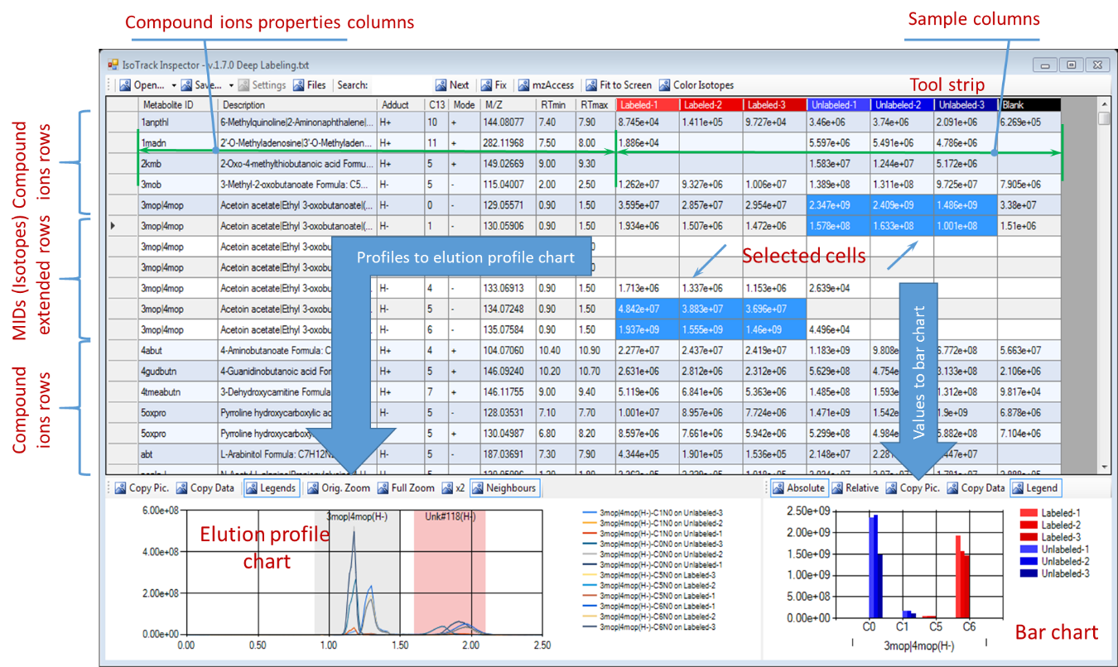

#### Isotopes Display

When you make left mouse button double click on the compound ion description (any of first eight columns) Inspector will extend compound ion row with additional rows for 13C isotopomers of compound. Number of rows will be the number of carbon atoms in compound. Cells in such additional rows will show ion current for particular isotopomer of compound in particular sample.

To hide isotope rows double click on the first isotope row again.

#### Cell Selection

When you select ion current cells in the main table ion current values are reflected on the bar chart and elution profiles corresponding to ion current in selected samples and compounds are shown on elution profile chart.

You can select any subset of the cells pretty much the same way as in Excel. Hold “shift” key to select range of the cells. Hold “ctrl” key to select arbitrary cells out of the range.

If you have selected cells related to the same compound, you will be able to change elution interval directly on elution profile chart.

#### How to Modify, Add and Delete Rows in Main Table

You can change values in any columns describing the compound except the “Metabolite ID” column. To start changing value press “F2” key. To finish changes press Enter. After you finished changes your input will be validated, and if columns are filled wrong (like if you have entered text into numeric field) you will be warned to cancel or continue editing. If you have changed columns related to RT-MZ coordinates, all the ion current cells will be updated after you finish editing.

You cannot change 13C isotopomers rows. Changes are only available for the base isotope. Changes, made to base isotope, will be reflected to the all of isotope rows.

To delete row select the full row and then press “Delete” key.

You can add data in row-by-row fashion at the end of main table. Move to the last string and fill all the columns, describing new compound with appropriate values. After you finish filling compound ion attributes, all the ion current cells will be filled automatically.

#### Order of Rows and Columns

Default order of rows in main table correspond to text file opened in Inspector. You can change it manually by editing that file (often manual manipulations on text file are more convenient than changing file with Inspector interface).

Main table also can be sorted by any of the column. To sort click on the column caption. First click will provide ascending sort order; second click is for descending order. Note, sorting by sample column can take relatively long time since it will retrieve data for all the ions.

First eight column are frozen in order since they describe target ion. Rest of the column describe particular samples and can be ordered in “Files” window.

#### Search

Inspector provides free text search by “Metabolite ID” and “Description” fields. To start search just start typing text for search in main Inspector window. Focus caret will be placed to “Search” string at the top of window. Search will continue as you continue typing. To move to the next text string fulfills search string press on the “Next” button on the top of main window.

#### Fixed Rows

If you need to compare values or elution profile of compounds, which are distant from each other in the main table, you can froze row of one of compound to the top of main table. To do it, Select any cell in first compound row and press button “Fix”. After that first compound row will be moved to the top of the table, colored light yellow, like it shown on the figure, and excluded from normal scrolling and sorting. As it shown on the picture you can fix multiple rows, all of them will be frozen at the top of the window.

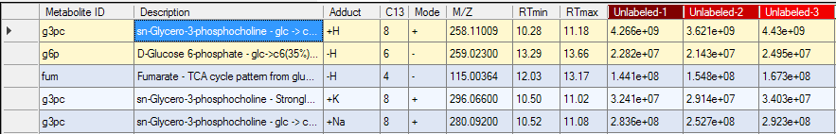

Then you can scroll to the second compound of your interest, select cells of your interest and compare that compounds.

To unfix string press “Fix” button once again having selection focus on the string you like to unfix.

#### Drag-n-Drop of Compounds

If you have two instances of Inspector opened, you will be able to drag and drop compounds from one instance to another. To do it press left mouse button on “Metabolite ID” of compound ion you like to copy to another instance and start dragging it to main table of another instance. After you drop compound to main table of second Inspector instance, it will appear there at the end of main table. Ion current cells will be filled from sample raw files described in target Inspector instance.

#### Fit to Screen of Main Table

“Fit to screen” locking button on the top of the window rescales sample columns of main table to fit all sample columns to the application window as it shown on the figure. If you have many samples, this option can be useful to overview sample state and column selection. To return cells to the normal width click on the “Fit to screen” once again and unlock it.



#### Color Isotopes

“Fit to screen” locking button on the top of the window colors extended isotopes with shades of red where intensity of shade corresponds to part of particular isotope in isotope distribution as it shown on the figure.

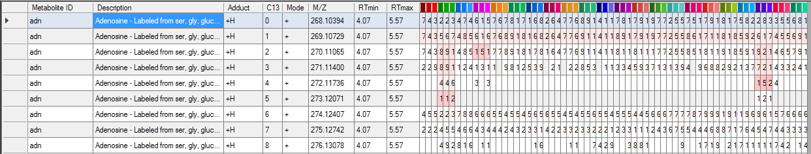

This option provides fast heatmap-like overview of isotopes distribution over set of samples and can be particularly useful in isotope tracing studies.

### Elution Profile Chart

Elution profile chart shows elution profiles of the compounds for selected cells in the main table for visual inspection of elution profiles.

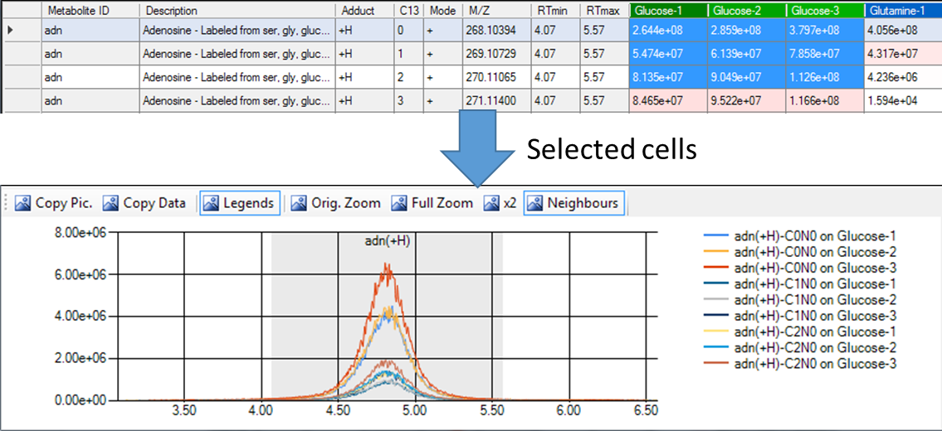

#### Elution Profile Scale Selection

The retention time (RT) interval for the chart covers compound elution time plus margins (margins are set in mzAccess settings window). You can control RT interval in a following ways:

* Zoom in with a mouse: Select with left mouse button down interval you need to inspect in details
* Buttons on the top of elution profile chart. “x2” button extends RT interval twice until it reaches the full RT of experiment. “Full Zoom” shows full RT of experiment.
* “Orig. Zoom” button will return chart to initial scale.
* Drag axis X of the chart to move to neighboring areas left or right.

You can also drag axis Y to explore low intensity details of elution profile.

As you change the scale of the chart, data for elution profile chart will be delivered dynamically from mzAccess service and chart will stay updated from raw data.

#### Selection of RT Interval

If all the selected cells in main table belong to the same compound, you can change RT interval directly in profile chart. To do it press key “ctrl” (mouse pointer will be changed to screen shot of arrow pointers with crossbar ) and holding this key select with left mouse button down new elution time interval of compound. After you release mouse left button RT interval will be updated on chart and in the main table. Cell values will be recalculated for new RT interval.

#### Neighboring Compounds

Button “Neighbors” at the top of profile chart make visible RT intervals of compound with about the same m/z (with mz deviation set in mzAccess window). It makes possible visual inspection of elution profile separation for compounds with nearly the same mass. Example of such compounds shown on the figure. Leucine is selected and available for inspection. Isoleucine is neighbor and shown with light red interval.

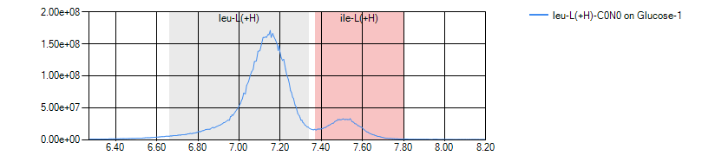

#### Copy Data from Elution Profile Chart

There are two options to copy data from elution profile chart: You can copy to clipboard picture as on the figure below with a “Copy Pic.” Button.

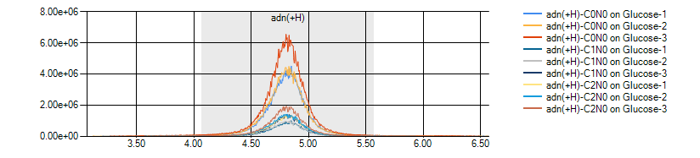

Otherwise, with “Copy data” button, you can copy to clipboard numerical data in text tab-delimited format and use this data with a software of your choose to visualize or process it. Example with Excel is shown on the figure below.

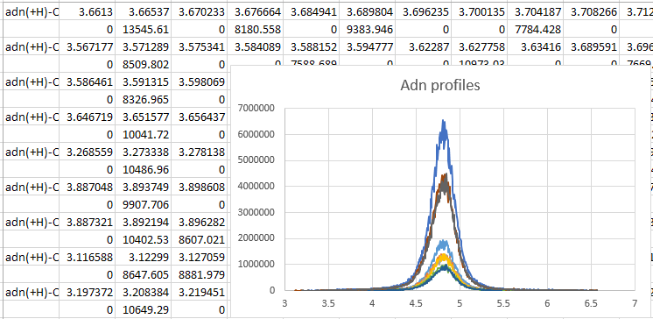

### Bar Chart

Bar chart shows together total ion current values of elution profiles for cells, selected in main table. Selected values are grouped first by “Metabolite ID” and then by 13C isotope. That make it easier to compare values then in numerical form in main table.

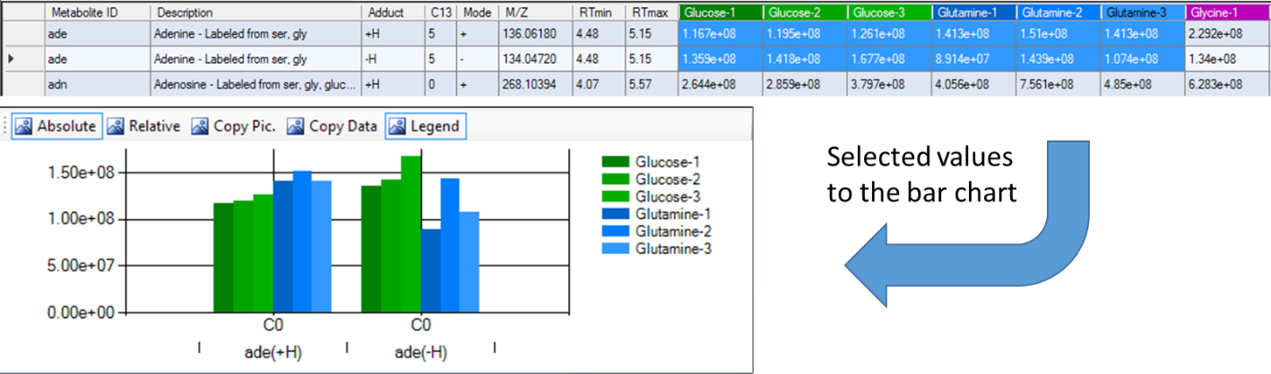

#### Absolute and Relative Scales

There are two exclusively mutual options of the cell values. First option shows cell values as it is, in absolute scale. The second option normalize values to be sum equal to one for each sample. This second option is specifically useful for isotope tracing experiments since isotope ratios of compounds are much more reproducible than absolute values. On example below adenosine isotopomers formed in presence of 13C enriched glucose and glutamine are shown in both scales.

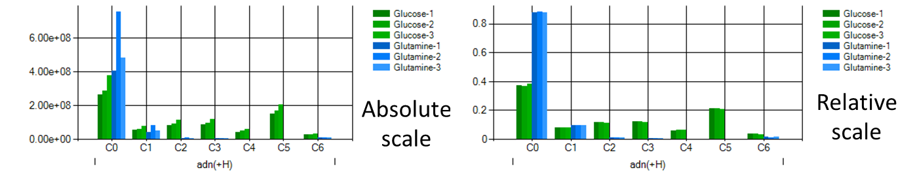

#### Copy Data from Bar Chart

As well as for elution profile chart, data from Bar Chart can be copied to clipboard both as picture (“Copy Pic.” button) and as tab-delimited text (“Copy Data” button). Text delimited data includes description of compounds taken from main table.

### Import and Export Data from Inspector Software

Main format of files to open and save is tab-delimited text format described in Input Data section above. Additionally, Inspector supports import of the same kind of information from .db3 files generated by the IsoTrack software.

Inspector can also save text files with all total ion current information collected. There is two items in drop-down “Save” menu at the top of main screen.

“Save Label-Free Report” menu item saves all collected information about base pure 12C isotopomer of all compounds. Such a text report correspond to main table content with all the isotope information hidden.

“Save Isotope Report” menu item saves all collected information about all carbon isotopomers of all compounds. Such a text report correspond to main table content with all the isotope information extended.

### File Safety Service of Inspector

Inspector checks if the content of main table has been changed. After any change, the symbol “*” appears in caption of main window. In case of changes, Inspector will prompt you to save the file before exit.

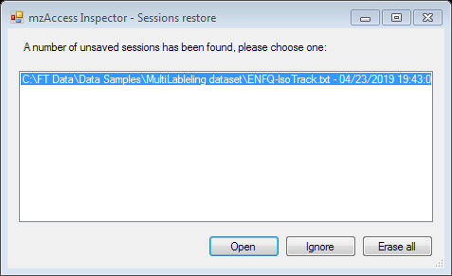If by some reason Inspector session has been finished unexpectedly, at next start Inspector will show you session restore window where you can choose if you will restore one of the broken session, erase them, or postpone your decision to the next time you will run Inspector.

The five most recently opened files in Inspector are also available in Recently Used Files list in “Open” drop-down menu.

1. [Profiling the Metabolism of Human Cells by Deep](https://www.ncbi.nlm.nih.gov/pubmed/30270114) [13](https://www.ncbi.nlm.nih.gov/pubmed/30270114)[C Labeling.](https://www.ncbi.nlm.nih.gov/pubmed/30270114) Grankvist N, Watrous JD, Lagerborg KA, Lyutvinskiy Y, Jain M, Nilsson R. Cell Chem Biol. 2018 Nov 15;25(11):1419-1427.e4.